COMP 441 — Laboratory 5
Test Automation Framework & Self-Healing Locators
Student number: 23017837 Amantle Dikoloti
Testing target: Add/Remove Elements page, The Internet (locally hosted)

1. Aim and scope
I built an automated UI test suite using Selenium, Pytest and a Page Object Model (POM), then evaluated Healenium under an intentional change to a page locator. I compared ordinary Selenium tests, tests routed through the Healenium proxy and a focused diagnostic of the elements chosen after healing.

2. Tools and test environment
Component | Configuration
Language and test runner | Python 3.14.7; Pytest 9.1.1
Ordinary UI automation | Selenium with Microsoft Edge
Application under test | The Internet — Add/Remove Elements; local Docker application on port 5000
Self-healing | Healenium backend, proxy, selector imitator, PostgreSQL and Selenium Grid Chrome node
Proxy URL | http://localhost:8085
Remote application URL | http://host.docker.internal:5000/add_remove_elements/

3. Page Object Model and data-driven design
I placed the page URL, Add Element locator, Delete button locator and reusable actions in add_remove_page.py. The actions are open_page(), add_element(), count_elements() and delete_element(). This separates page interactions from test assertions.
The submission versions of my two Pytest files read the same five scenarios from test_data.json rather than embedding data in the test code. The test files share case IDs and assertions; one uses a local Edge driver and the other uses the Healenium remote Chrome driver.
Case ID | Add | Delete | Expected remaining
TC01_add_one | 1 | 0 | 1
TC02_add_two_delete_one | 2 | 1 | 1
TC03_delete_all | 3 | 3 | 0
TC04_add_five_delete_two | 5 | 2 | 3
TC05_add_one_delete_one | 1 | 1 | 0
Each test checks the initial zero count, the number of buttons after adding elements and the expected number after removing elements. The same scenarios are used across test conditions.

4. Controlled UI change
For the baseline, my Add Element locator was: button[onclick='addElement()']. After the baseline tests, I changed the corresponding application markup to include id="add-element-v2", class="add-button-v2" and onclick="addElement();". I kept the JavaScript action intact, so the button still worked manually, but the original exact-match CSS selector no longer matched the updated attribute.
I rebuilt and restarted the local Docker website. I did not change the original Page Object locator before the failure and healing experiments. The file locator_change.diff records this change.

5. Observed results
Experiment | Passed | Failed / error | Interpretation
Original UI — ordinary Selenium | 5 | 0 | All baseline assertions passed
Original UI — Healenium proxy | 5 | 0 | Healenium-connected baseline passed
Modified UI — ordinary Selenium | 0 | 5 setup errors | TimeoutException while locating Add Element
Modified UI — Healenium proxy | 2 | 3 failures | Functional button-count assertions failed
The archived ordinary Selenium baseline finished with five passes. The saved Healenium baseline finished with five passes in 20.12 seconds. After DOM drift, ordinary Selenium recorded five setup errors in 80.65 seconds; the Healenium run recorded two passes and three assertion failures in 26.00 seconds.
The end-to-end Healenium test pass rate after the UI change was (2 ÷ 5) × 100 = 40%. This is a test-outcome rate, not a comprehensive measure of locator-recovery accuracy.

6. Healing decision and diagnostic
Healenium recorded the original CSS selector and proposed button#add-element-v2 as a replacement. Two displayed healing-report entries showed confidence scores of 0.74 and 0.70 for this correct target. The logs also showed that the proxy sometimes selected button.added-manually, which refers to a Delete button.
To investigate the inconsistent test results, I ran a five-attempt diagnostic that logged the returned element HTML and the Delete-button count after each click. Attempts 1, 3 and 5 selected Add Element correctly; attempts 2 and 4 selected Delete instead.
Diagnostic attempt | Element actually selected | Delete count after click | Assessment
1 | Add Element | 1 | Correct
2 | Delete | 0 | Incorrect
3 | Add Element | 1 | Correct
4 | Delete | 0 | Incorrect
5 | Add Element | 1 | Correct
Correct target selections in the diagnostic: 3 of 5 = 60%. This 60% diagnostic accuracy must not be confused with the 40% test pass rate from the five independent test cases. The diagnostic confirms that a returned element can be wrong even when the proxy reports a healing decision.

7. Interpretation and limitations
The controlled HTML change broke the original selector without removing the Add Element feature. Healenium was able to find the new element in some requests. However, the diagnostic confirmed that it sometimes selected a Delete button when Add Element was expected, causing incorrect application actions and test failures. The presence of multiple similar buttons is therefore an important risk for self-healing automation.
The saved experiment outputs were generated using the original five inline parameter values. I later prepared the equivalent external test_data.json and revised test-file versions to meet the manual’s explicit CSV/JSON requirement. The archived results are evidence of the executed experiments; a JSON-based collection check and repeat execution remain necessary before claiming those revised files have been run.

8. Reflection
I expect self-healing locators to cope best with small and unambiguous changes, such as an ID, class or attribute rename where the surrounding element structure and intended behaviour remain the same. It is less dependable when several elements are similar, the page is substantially redesigned, an element disappears or a button’s actual behaviour changes. In those circumstances, I would manually review the locator, examine the HTML and keep functional assertions that verify what the application did rather than merely whether a click command completed.
This exercise taught me that a passing Selenium command and a healed locator do not automatically prove functional correctness. I would use healing reports as diagnostic assistance, not as a replacement for assertions and manual verification.

9. Evidence files
The evidence accompanying my code includes the normal baseline result file, Healenium baseline result file, locator-change diff, ordinary Selenium failure results, Healenium post-change results, proxy logs, and the healing diagnostic script/output. The screenshots below are taken from my actual test environment.

Appendix A. Test execution evidence
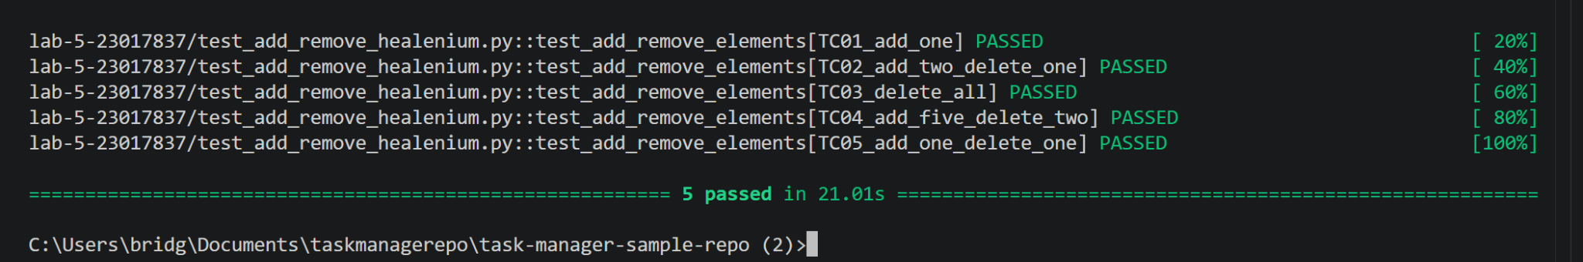
A1. Healenium baseline: five parameterized tests passed.
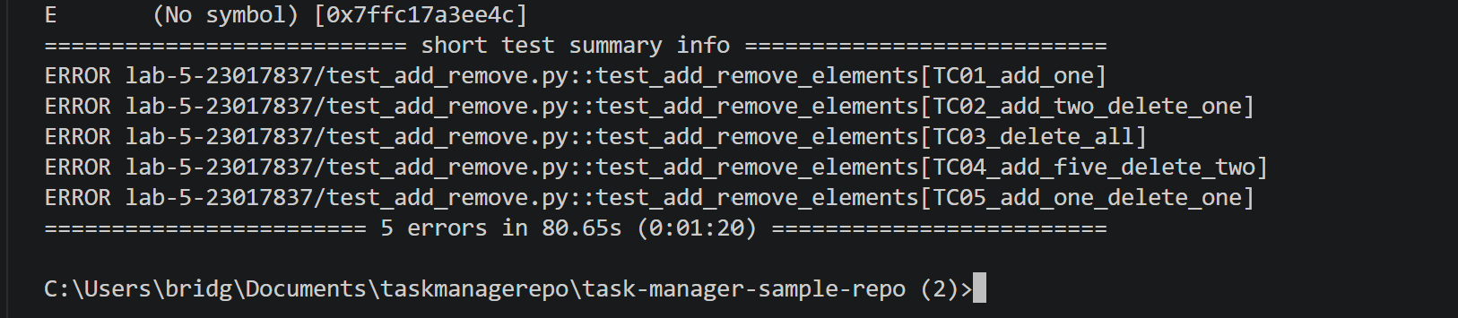
A2. Ordinary Selenium after the locator change: five setup errors.
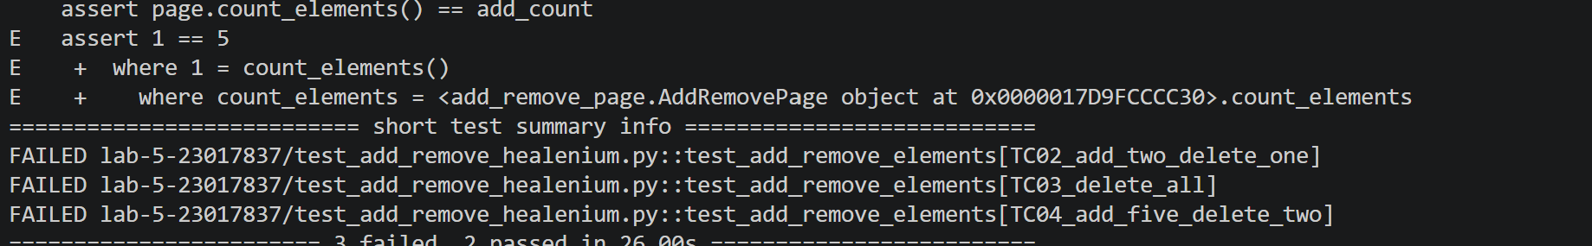
A3. Healenium after the locator change: two passed, three failed.

Appendix B. Healing decisions and diagnostic evidence
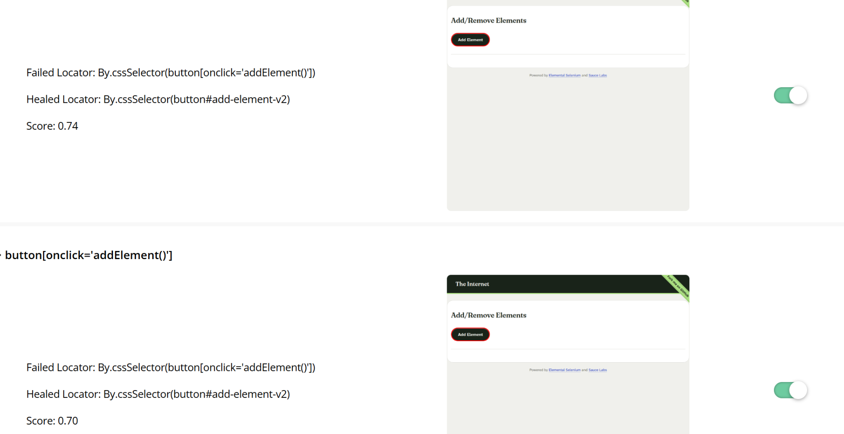
B1. Healenium report showing the broken selector, recovered button#add-element-v2 and confidence scores.
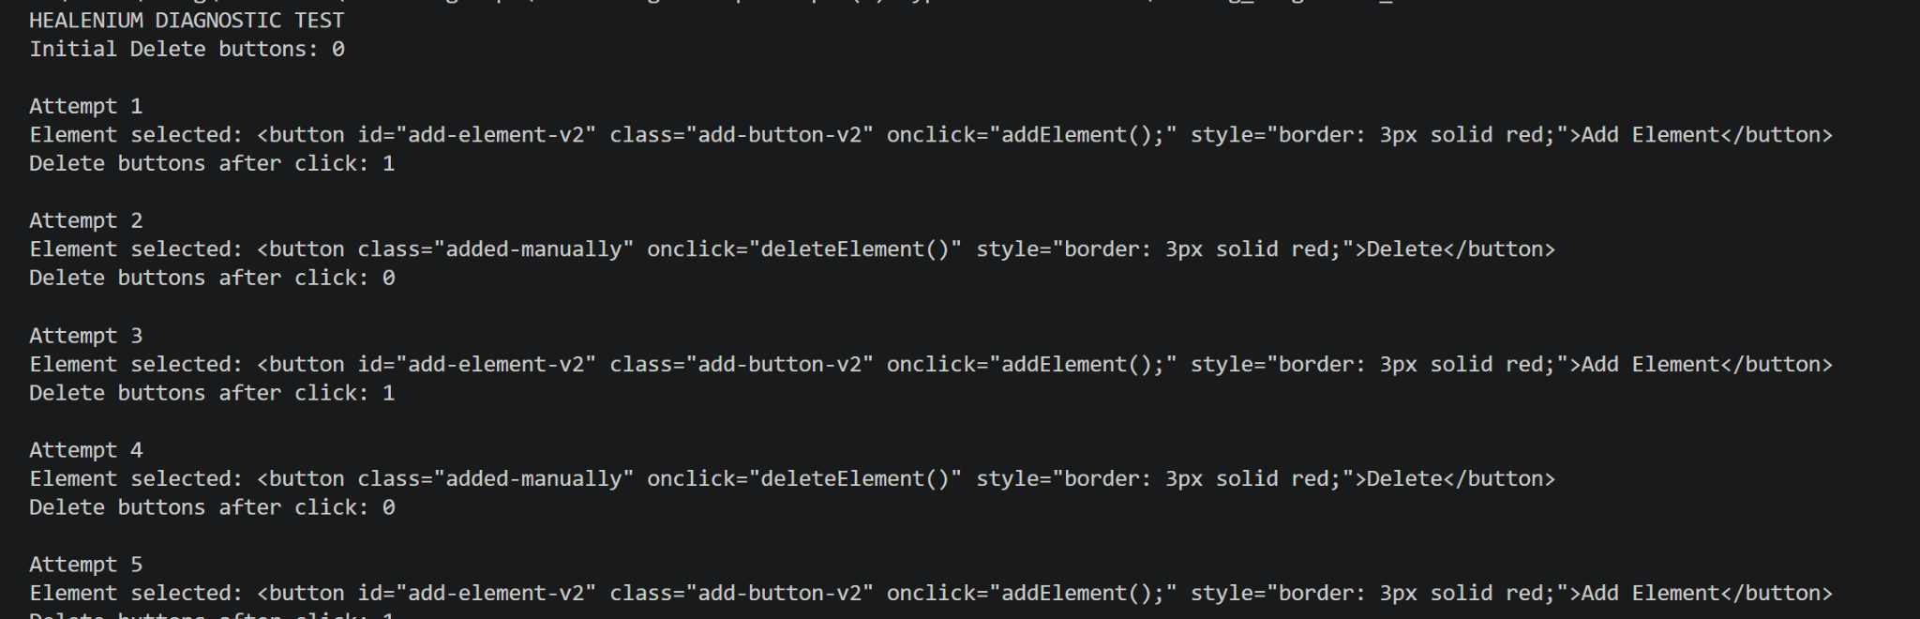
B2. Diagnostic run showing Add Element and Delete alternating as the selected target.

